**RESUME**

S. Boomika

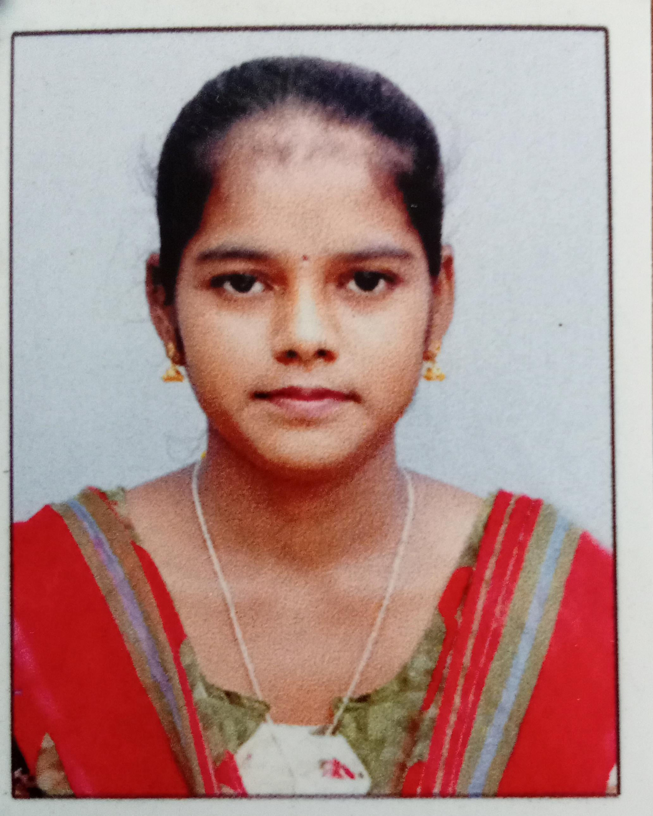

Cell : 9342023735

ADDRESS:1/57/1,perumal kovil street, kallikkudi post, thiruvarur thaluk, 611101 Email id :boomikaselvam78@gmail.com

CAREER OBJECTIVES:

I’m just another university graduate,eager to get his first teaching job .i have passion for innovative teaching methods , sush as leanring classroom ,and it is the main reason why I decided to apply for a job with your private school.people say that I am a great listener and communicator in general,and it is easy for me to win the hearts of children.but I honestly believe that I still have to improve on many things ,if I am to become a great teacher one day. Iam eager to give it my best though, and your school is an idea place to follow my dreams .

EDUATION:

*CLASS X:*

*Sri. G. R. M. Girls. Hr. Sec. School. Thiruvarur*

*Medium: Tamil*

*Year of passing:2019*

*Grade:335*

*CLASS XII:*

*Sri. G. R. M.Girls. Hr. Sec. School. Thiruvarur*

*Medium: Tamil*

*Year of passing:2021*

*Grade:442*

*COLLEGE:*

*III-B.sc (Computer science) final year student*

*Thiru.Vi.Ka.Govt arts &S*cience, *college thiruvarur*

*Bharadhidasan university*

AMBHITION:

* *I Try to well salary for government job*
* *I Will be create App developer,teaching fields.*

HOBBIES:

*Listening music I love leader ship, Drawing , game , writing , cooking, reading books.*

DECLARATION:

*I hereby declare that all above mentioned information is true to the best of my knowledge and belief.*

YOUR’S FAITHFULLY:-

S. BOOMIKA